**Question 1**

*“To the user the UI is the system. Most interfaces need to be designed to accommodate both the novice(beginners) and expert (advanced) users at the same time.”*

Do you agree with the above statement? Give 2 examples (**own examples**) to support your answer.

Yes, I agree with these, the best UI design is one that can be used by both novice and experts users, accommodate for their needs.

Novice users are unfamiliar with the system, they are the beginners’ levels users while experts users already familiar with the systems and they need to execute/perform their tasks efficiently or explore uncommonly used or new functionalities.

Eg 1. Word processor with shortcut keys for expert. Or ribbons for novice users to click on the button such as copy button, paste button, whereas the advanced users use short cut keys to perform the same task, ctrl + c and ctrl + v, expert users prefer not to use too many mouse clicks, mouse click action need extra time and efforts. Novice users need step by step guidance to perform the required task, speed is not a matter for them yet, they need to perform the required task in the correct way compared with expert users in which speed is a matter for them.

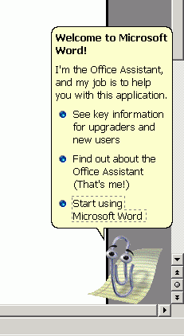

Eg 2. OS where you can have new users or expert users, expert users use command line interface a lot compared with GUI interface.

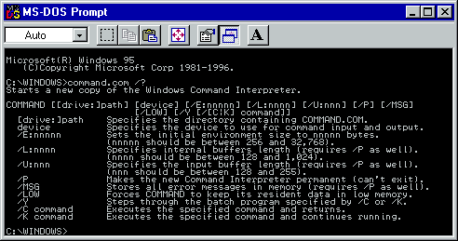

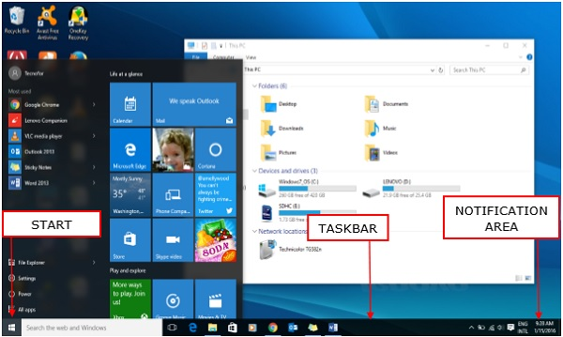

Depends on the frequency of use. If a system is only used a few times (e.g. library checkout), then probably it’s to cater for novice to intermediate users. However, if a system is used very frequently (OS), then users can range from novice to experts users such as word processor software novice users used to perform basic editing documents, whereas advanced users used it to perform advanced functions such as mail merge.

**Question 2**

(a) How do the requirements of an expert user different from those of a novice users? Present your answer in a table format.

(b) If you are developing a system that needs to cater for both the novice and expert users at the same time, which category of user would you pay more attention to? Give reasons for your answer.

|  |  |
| --- | --- |
| **Novice user requirements** | **Expert user requirements** |
| Needs meaningful feedback messages explaining problem in detail such as what mistake did they make | Short and concise feedback message would do, they need to save time and effort, their focus on the productivity |
| Might have difficulties remembering system details, functionality, need icon to help them to remember better | Have strong knowledge of the system already, they know the systems features very well, |
| Easy to learn | Fast way to execute or perform the task, need short cut keys |
| Uses basic functions only | Uses advanced functions |
| Often requires assistance, F1 menu | Does not require much assistance |

For example MS excel users , novice users will click the sort button to sort data, expert users will use the macros to record the sorting procedures and create a custom made button in excel, to perform the sorting in future. Expert users of ms excels can customize ms office interface to suit their specific needs. Use macros to record the procedures, stored them, in future play back the recorded macros.

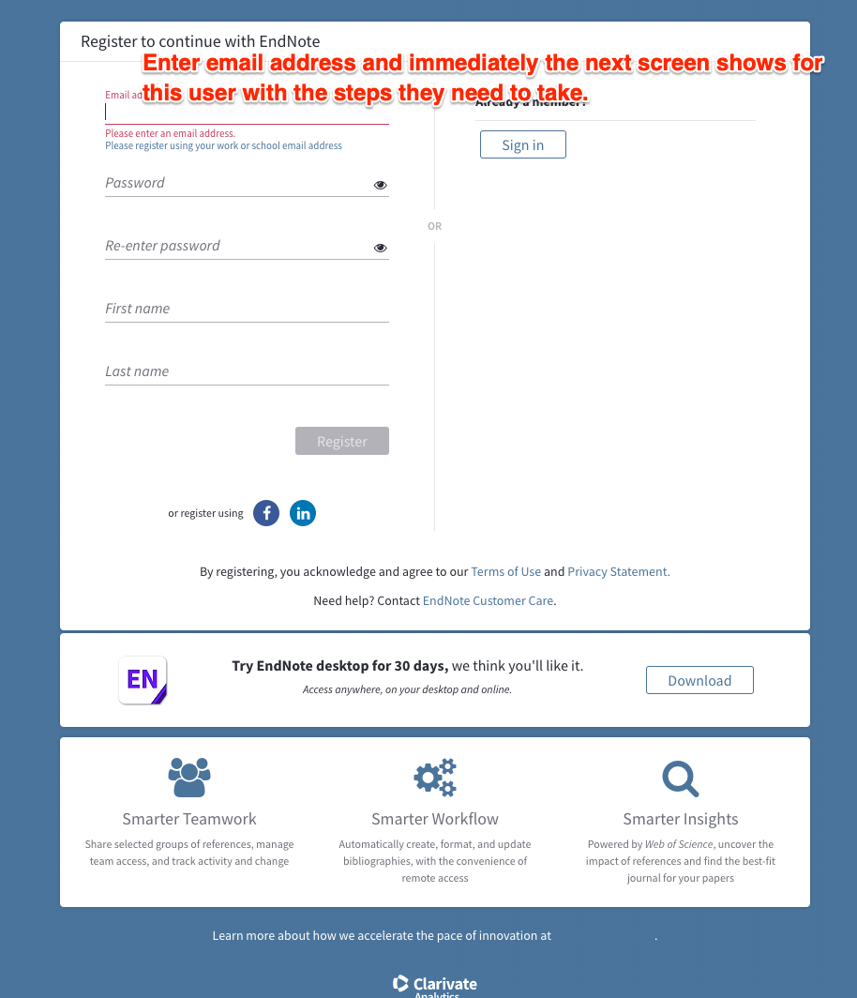

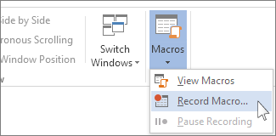



Novice users need to pay more attention to them because they do not know much of the system and as such need more guidelines to help them to understand and use it in order to prevent them from being lost or confused. This includes matching their mental models(cognitive studies- how they learn and remember), knowledge, level of computer experience, age and many other attributes.

# Question 3

To design an effective interactive system, it is necessary to know the answers to the following 3 questions:

1. Who are the users?
2. What are the tasks?
3. What is the environment in which the system will operate?

Give reasons why it is important for a designer to have the answers to the above 3 questions?

So that they can identify the users, their background, goals and values, and their mental models. Once users are identified, the designer needs to perform task analysis on the way user perform their current job with an existing system. The designer then identifies these tasks and translate them into a user interface. The environment is where the system which provides the physical inputs/outputs. This is so that the UI design used is suitable for the specified environment. This is known as contextual inquiry, the first task of UI design process.

For example in the assignment we come out with the user persona first, then we perform hierarchical task analysis, finally we explain in what environment the user perform the task, Thomas the interior designer who want to purchase the artwork, at the indoor exhibition hall.